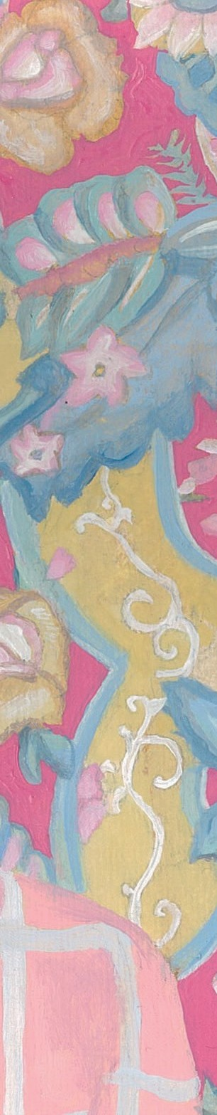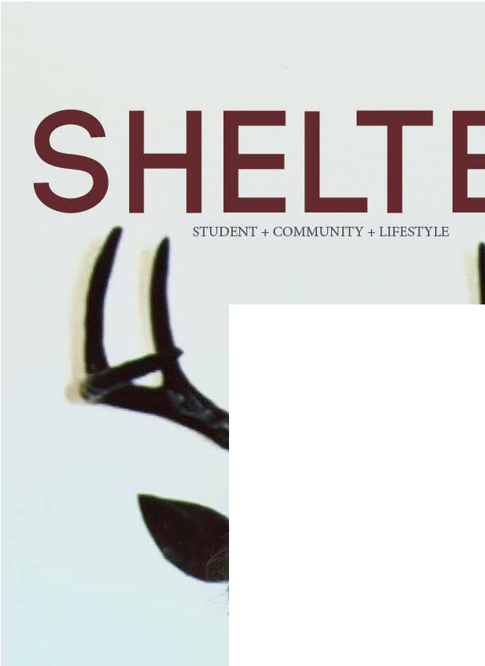

STUDENT + COMMUNITY + LIFESTYLE

SHELTER

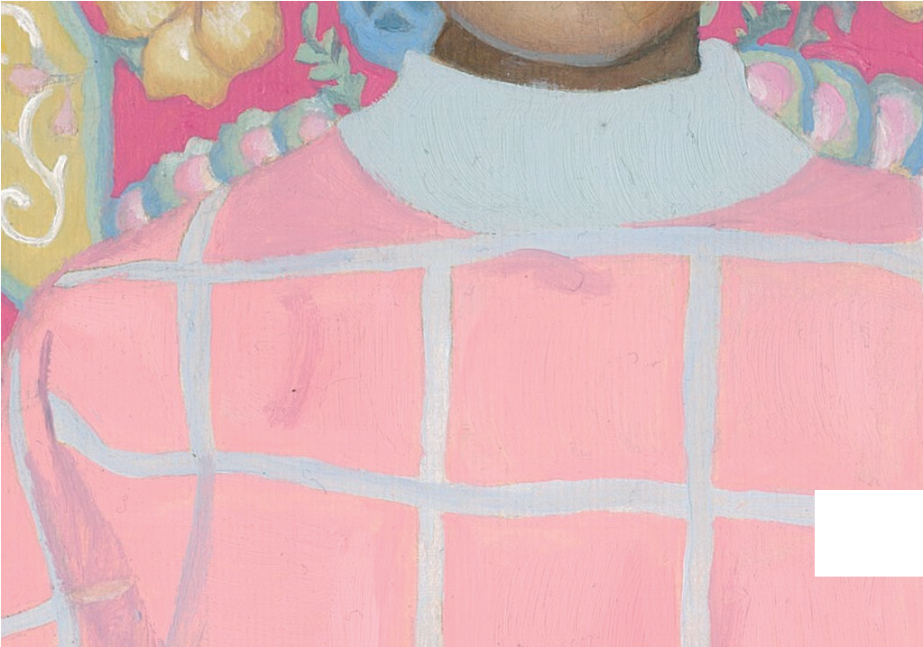

For sale from Rangi online store https://nz.patronbase.com/_RangiRuru/Store From 31st October 2017

ISSN 2537-9399

Vol.2 2017

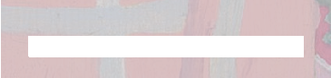

THE AROHA EDITIO



What is SHELTER?:

SHELTER is an annual print magazine produced by the students of Rangi Ruru Girls’ School in Christchurch, New Zealand. This is an integrated, edited magazine with high production values and content that speaks to our wider community. It is envisioned that the annual print magazine will be a collector’s item, containing content that is timeless.

The intended SHELTER audience is present and past students and staff as well as people who have an interest in girls’ education and our wider community. SHELTER takes the best of our student voice. The brief is to produce content that inspires, challenges and empowers our audience and promotes the RAN- GI values:

## Respect

* Aroha
* Endeavour and enthusiasm
* Generosity of Spirit
* 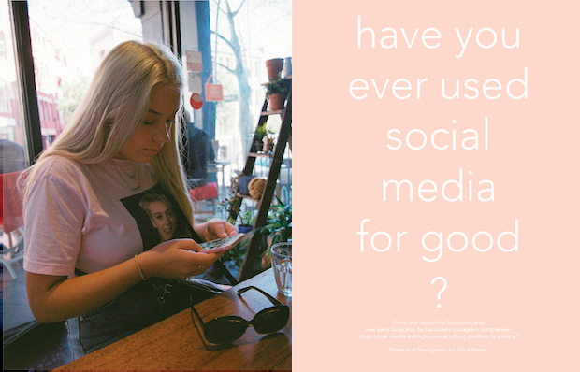Integrity and honesty

What makes SHELTER unique?

SHELTER nurtures and celebrates the diverse talents in our school com- munity.

Our magazine has high production values with a commitment to promoting student voice, critical thinking and creativity through excellence in visual communication and design. In short, Shelter is coffee table worthy.

We pride ourselves on celebrating the diverse voices and strengths within our community through content and design elements.

SHELTER allows students to apply their learning through the creation of content for our diverse magazine audience. The content is cross-curricular and encompasses the whole student body.

The magazine has sections to reﬂect the diverse thinking and content creation of students at Rangi Ruru. These are:

# Student

* **Community**
* **Lifestyle**